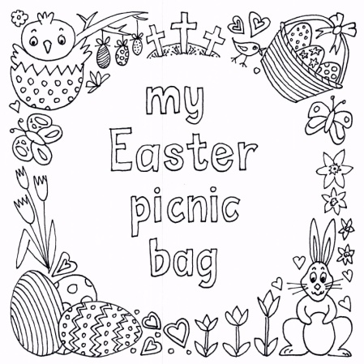
Over the school Easter holidays Church of Our Saviour is offering a children’s picnic bag scheme for those who are struggling at the moment. This will be available on weekdays between Monday 29th March to Friday 9th April and you can dip in and out as suits you.
What will be included?
- A choice of ham/ham & pickle, cheese/cheese & pickle, tuna or jam sandwich
- A choice of carrot sticks, cucumber sticks or baby tomatoes
- A choice of an apple, satsuma or banana
- A choice of apple or orange juice
- A bag of crisps
- Yoghurt
- Sweet Treat

The picnic bags must be pre-ordered – Please complete one form per child

If this is something that you would be interested in the order form(s) for your child/children is below. If you have any questions please do not hesitate to contact either: Claire - 07807 472414 or Judy - 07946 535198
or email mypicnicbag@churchoos.org.uk

Please email your completed form to mypicnicbag@churchoos.org.uk by Wednesday 24th March

Hope to see you soon

Claire Musselwhite, Judy Woosnam and the My Picnic Bag Team

Parent’s Name ................................................. Contact Number .....................................

Address .............................................................................................................................

Child’s Name ............................................................ Age ..............................................

Collection (from Church of Our Saviour CM2 6ST) - 10.30/11.00 □
or Delivery □ Please provide postcode and entry code if required ...........................

 | Ham, Cheese, Tuna or  Jam Sandwich | Pickle in ham or cheese sandwich?  Yes/No | Apple,  Banana or  Satsuma | Carrot Sticks,  Cucumber  Sticks or  Baby Tomatoes | Crisps -  Yes/No | Yogurt -  Yes/No | Sweet Treat  Yes/No | Orange or  Apple Juice
Monday

Tuesday

Wednesday

Thursday

Friday

Please state the number of sandwiches required: 2 or 4 ................................................

Any dietary requirements/allergies? Please provide details:

..........................................................................................................................................

Please email your completed form to mypicnicbag@churchoos.org.uk
by Wednesday 24th March

